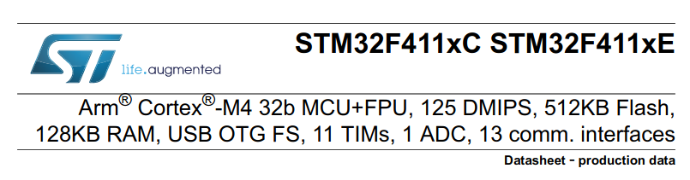

1. INTRODUCTION:

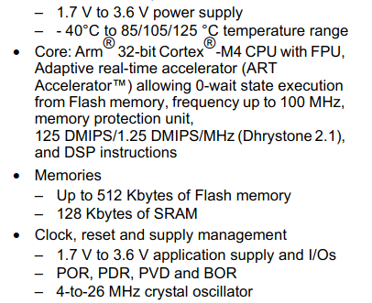
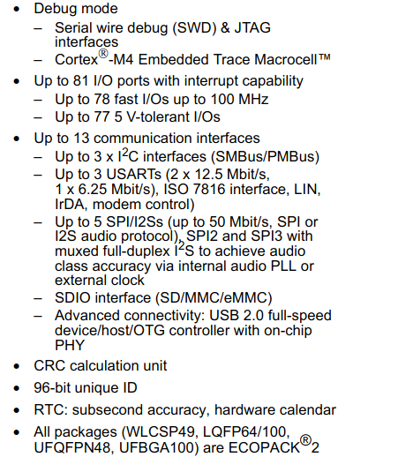

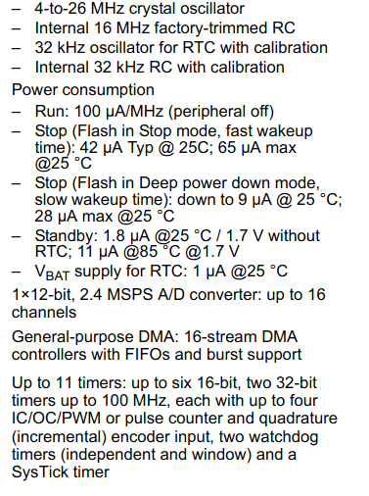
The STM32F411X C/X E devices are based on the high-performance Arm® Cortex® -M4 32-
bit RISC core operating at a frequency of up to 100 MHz. The Cortex ®
-M4 core features a
Floating point unit (FPU) single precision which supports all Arm single-precision data-
processing instructions and data types. It also implements a full set of DSP instructions and
a memory protection unit (MPU) which enhances application security.

Reduced Instruction Set Architecture (RISC) –

Simpler instruction, hence simple instruction decoding.
- Instruction comes undersize of one word.
- Instruction takes a single clock cycle to get executed.
- More general-purpose registers.
- Simple Addressing Modes.
- Fewer Data types.
- A pipeline can be achieved.
The main idea behind this is to make hardware simpler by using an instruction set composed of a few basic steps for loading, evaluating, and storing operations just like a load command will load data, a store command will store the data.

Complex Instruction Set Architecture (CISC) –

The main idea is that a single instruction will do all loading, evaluating, and storing operations just like a multiplication command will do stuff like loading data, evaluating, and storing it, hence it’s complex.
Complex instruction, hence complex instruction decoding.
- Instructions are larger than one-word size.
- Instruction may take more than a single clock cycle to get executed.
- Less number of general-purpose registers as operations get performed in memory itself.
- Complex Addressing Modes.
- More Data types.
A floating-point unit (FPU) is that part of a computer’s processing unit that allows it to perform floating-point calculations. Floating-point numbers contain fractions or decimal points, such as 8.565 and 0.0158, and operations that include them are called “floating-point calculations.”

The Memory Protection Unit (MPU) is a programmable unit that allows privileged software, typically an OS kernel, to define memory access permission. It monitors transactions, including instruction fetches and data accesses from the processor, which can trigger a fault exception when an access violation is detected.
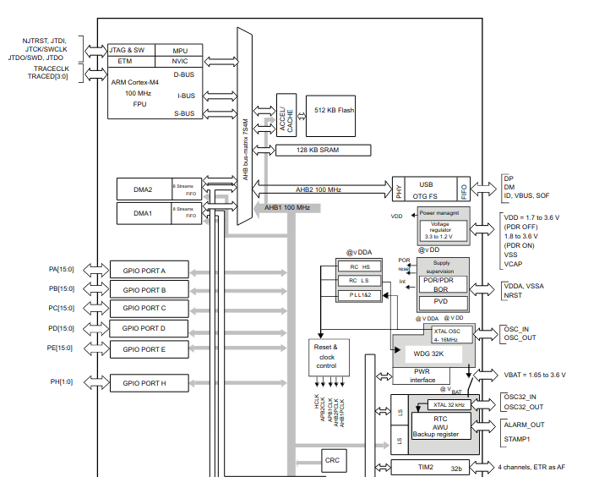

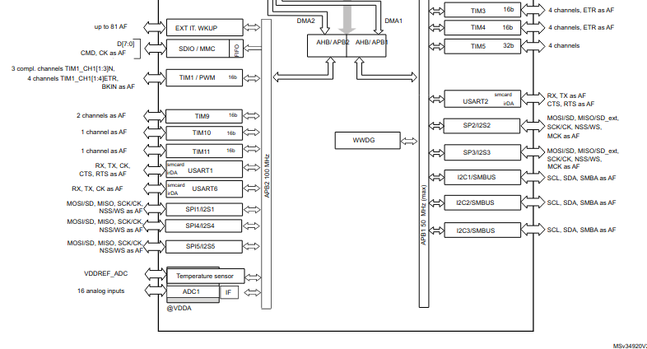
Clocks and startup
On reset the 16 MHz internal RC oscillator is selected as the default CPU clock. The
16 MHz internal RC oscillator is factory-trimmed to offer 1% accuracy at 25 °C. The
application can then select as system clock either the RC oscillator or an external 4-26 MHz
clock source. This clock can be monitored for failure. If a failure is detected, the system
automatically switches back to the internal RC oscillator and a software interrupt is
generated (if enabled). This clock source is input to a PLL thus allowing to increase the
frequency up to 100 MHz. Similarly, full interrupt management of the PLL clock entry is
available when necessary (for example if an indirectly used external oscillator fails).
Several prescalers allow the configuration of the two AHB buses, the high-speed APB
(APB2) and the low-speed APB (APB1) domains. The maximum frequency of the two AHB buses is 100 MHz while the maximum frequency of the high-speed APB domains is 100 MHz.

